**ASEN 5070-Statistical Orbit Determination**

**Homework 2**

**Zach Dischner**

**September 11, 2012**

MATLAB was used for all computation required in this assignment. I used a combination of built in functions, functions from homework 1, and functions written specifically for this assignment. All scripts and code sets are available if they are needed. However, they are not attached as that was not required in the assignment.

1. **A-Cartesian Partial Derivatives**

The Cartesian partial derivatives of the 2-body gravitational problem with J2 perturbations were computed symbolically in MATLAB, and can be shown below. A hand computation of is attached in Appendix A for verification purposes.

Table : 1A Solutions

|  |  |
| --- | --- |
| **Term** | **Value** |
| U | Macintosh HD:Users:zachdischner:Desktop:Screen Shot 2012-09-12 at 11.33.00 PM.png |
|  | Macintosh HD:Users:zachdischner:Desktop:Screen Shot 2012-09-13 at 1.35.43 PM.png |

1. **B-Plot of Keplarian Orbit Elements**

Using MATLAB to then integrate the Cartesian equations using the results from Table 1 for one full day, I converted the Cartesian ECI Position and Velocity vectors into Keplarian components. The first step was performed with *ode45* with a *1e-12*tolerance. The conversion was performed using the same ECI to Keplarian coordinate transformation as used in Homework assignment 1.Plots of a, e, i, , , and Tp versus time are shown below. The constants and known variables are given, and provided again below.

|  |  |
| --- | --- |
| **Definitions** | **Initial Conditions** |
| Macintosh HD:Users:zachdischner:Desktop:Screen Shot 2012-09-13 at 2.41.34 PM.png | Macintosh HD:Users:zachdischner:Desktop:Screen Shot 2012-09-13 at 2.42.49 PM.png |

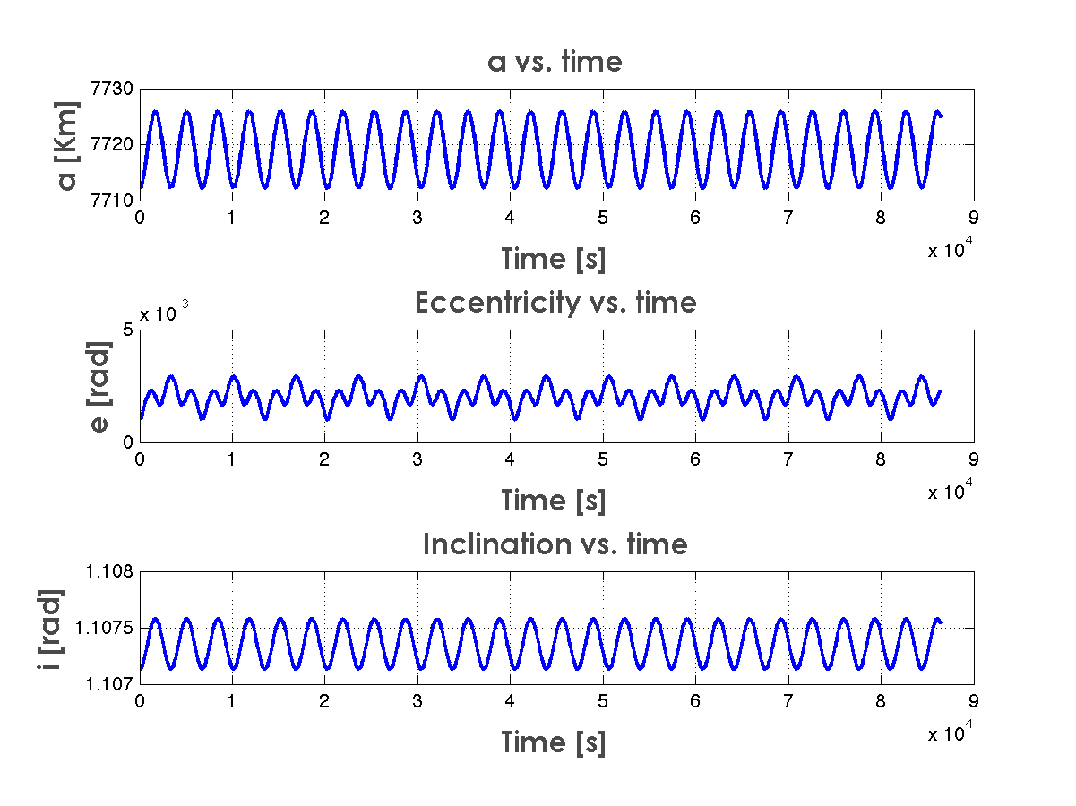**Figure 1: a,e,i vs. Time**

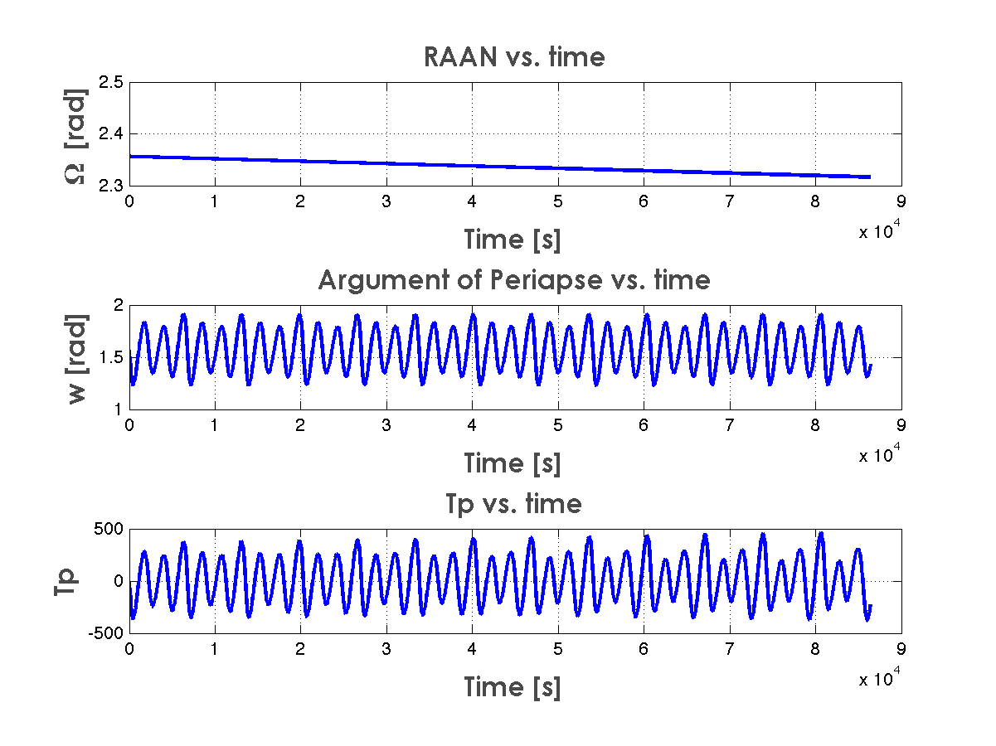

Figure 2: RAAN, Argument of Periapse, and Tp Vs Time

Recalling the result from this same integration performed without the J2 perturbation, there is evidence of the J2’s affect on the Keplarian orbit elements.

First evident is the fluctuation in orbit semi-major axis, *a*. For an orbit that is nearly totally circular (e=9.9e-4 from HW1 solutions), the semi-major axis shows some fluctuation. The magnitude of this fluctuation is slightly higher than was seen when investigated previously using only a 2-body gravity model. With this fluctuation is a fluctuation in *e*, the orbit’s eccentricity. This matches intuition, since as the satellite’s orbit brings it in line with the equator, increased gravity will pull the satellite closer to the earth. In the same fashion, when the satellite gets further from the equator, the decreased gravity will allow the orbit to stray further from earth. In this manner, the orbit will become more elliptic (higher *e*) at different points throughout the orbit, depending on the initial position and eccentricity.

Next, we can see that the orbit’s inclination (*i*) oscillates with the orbit period. In this inclined orbit, the earth’s oblateness has the effect of acting like a torque on the satellite. At periapsis and apoapsis, this is most easily visualized. There is the main gravitational force between the satellite and the earth’s center. There is also an additional component of gravitational force that comes from the excess mass built up around the earth’s equator, which essentially pulls the satellite towards that build up. This combination of forces torque the orbit place and create oscillations in the orbit’s inclination. This is evident in Figure 1 above.

In the same manner as discussed above, the orbit argument of periapsis () has repeating oscillations with time. This shows that the orbit’s orientation with respect to the earth and shape are changed slightly throughout the orbit by the effects of earth’s oblateness.

Perhaps the most important effect of the J2 perturbation is in the Right Ascension (). This is where the orbit crosses from below to above the Earth’s equatorial plane. Seen in Figure 2 above, the Right Ascension decreases steadily throughout the two-day period examined. In orbit terms, this means that the orbit has swung a small amount to align itself in the direction of the Vernal Equinox. decreases only slightly; less than 0.04 rad in two days. However, over a long mission, this precession could become problematic.

1. **C-Plot of Specific Orbit Energy**

Figure 3 below shows a plot of the change in specific orbit energy of the satellite over a two-day period, with the effect of earth’s oblateness included throughout the orbit integration. That is, this is a plot of vs. time.

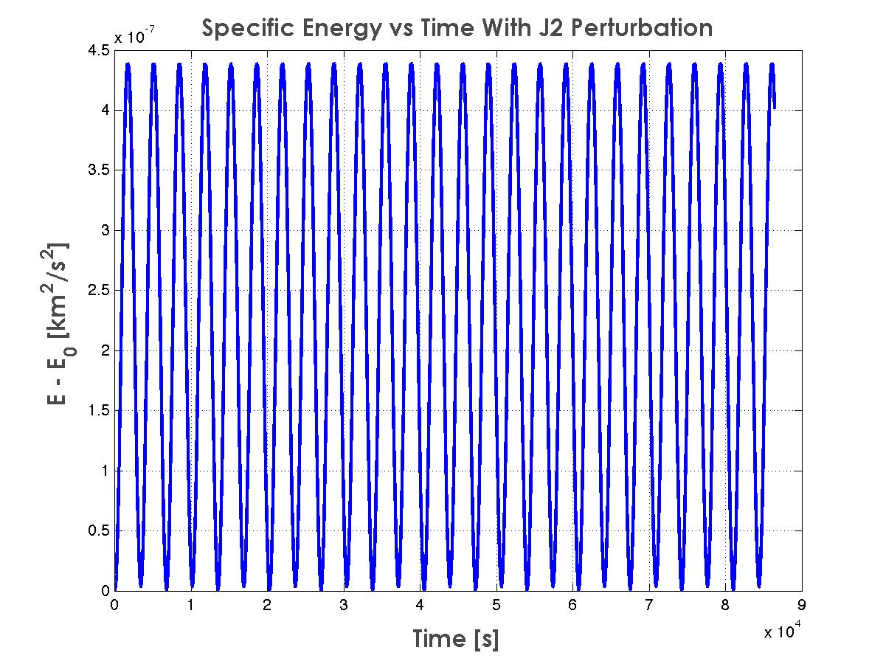

Figure 3: Specific Energy vs. Time with J2 Effect

The specific orbit energy oscillates in its deviation from its original specific energy with the same frequency modes as seen in the previous plots of Keplarian orbit elements. The key thing to note above is that there is no overall trend or direction, just a repeating oscillation on a very small scale. This makes sense because gravity, no matter the distribution, is a conservative force, and no notable change in total energy should occur. The above plot shows changes in energy that are very small, and due to integration and numerical precision errors, not a true change in orbit energy.

1. **C-Plot of hk, Orbit Angular Momentum**

Similarly to specific orbit energy, the *k* component of angular momentum in an orbit should remain constant in a conservative system. To verify this, I first calculated the angular momentum vector:

**EQ (1)**

Next, I plotted the component of the angular momentum versus time for the same two-day period. This plot is shown below.

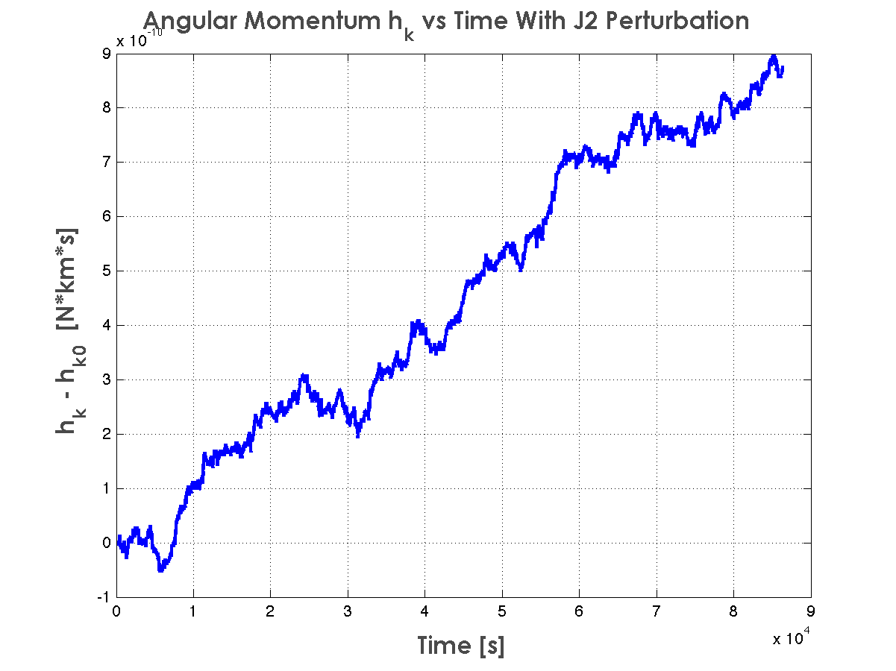Figure 4: hk vs. Time with J2

Again, there is some movement of the *hk* vector with time. But the scale is so small that it can be attributed entirely to errors in orbit integration, and numerical precision limitations.

1. **A-Integration of Orbit Path with J2 and Atmospheric Drag**

This problem now required the integration of the 2 body equations of motion, now with J2 perturbations as well as atmospheric drag factored in. Atmospheric drag’s effect on the equations of motion was given as an pure acceleration for simplicity of implementation.

|  |  |
| --- | --- |
| ***aDrag*** | **Constants/Definitions** |
| Macintosh HD:Users:zachdischner:Desktop:Screen Shot 2012-09-13 at 3.10.08 PM.png | Macintosh HD:Users:zachdischner:Desktop:Screen Shot 2012-09-13 at 3.10.18 PM.png |

The drag term for acceleration was added in to my calculation of the Velocity and Acceleration vectors from input Position and Velocity, the function that *ode45* uses to perform its numerical integration of the satellite’s orbit. Recall, to perform an orbit position/velocity integration, MATLAB requires a function that takes position/velocity as an input, and outputs their derivative, i.e. position/velocity 🡪 velocity/acceleration. Since the new drag term is given as an acceleration, it can simply be added to that differentiation function.

In MATLAB, I then performed a new integration of the initial *[R V]* vectors of a satellite using equations of motion for a 2-body system with the J2 effect and atmospheric drag factored in. Then, I converted the resulting estimation for position and velocity time profiles to Keplarian profiles throughout the 2-day period using the same *RV2Keplar* function that was used in homework 1. First, I computed the change in total energy over time from its initial state. See the plot below.

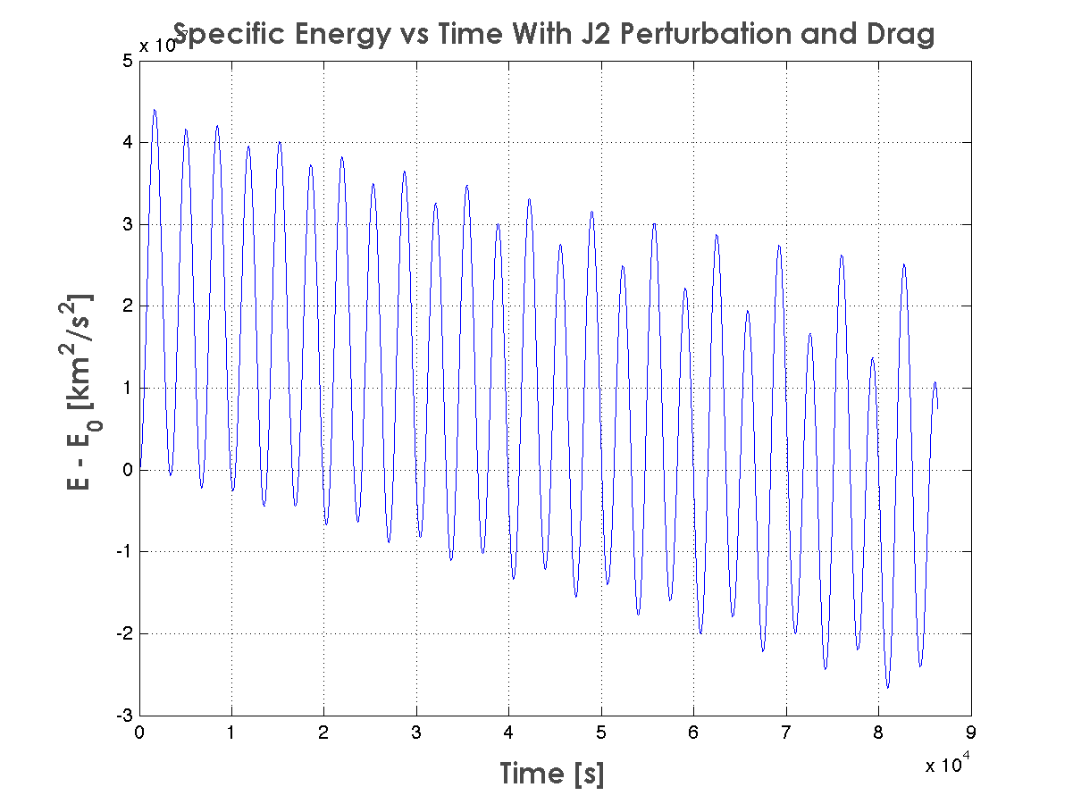

Figure 5: Specific Energy with J2 and Drag

Though the scale is small in Figure 5 above, it is clear that the overall trend indicates decreasing specific Energy. Given enough time, this would become a big agent of change for the orbit. This is because while gravity is a conservative force, drag is non-conservative. Energy is actually lost in this system as the satellite experiences high atmospheric drag. The above plot shows just that.

**2.0 B-Comparison of Keplarian Elements**

Next, a comparison between the solutions of the 2-body + oblateness problem, and the one with atmospheric drag added in was performed. For each orbit element, I compared the time predictions with those of just the 2-body + oblateness problem. These comparisons are shown in the following plots. Below, read E as .

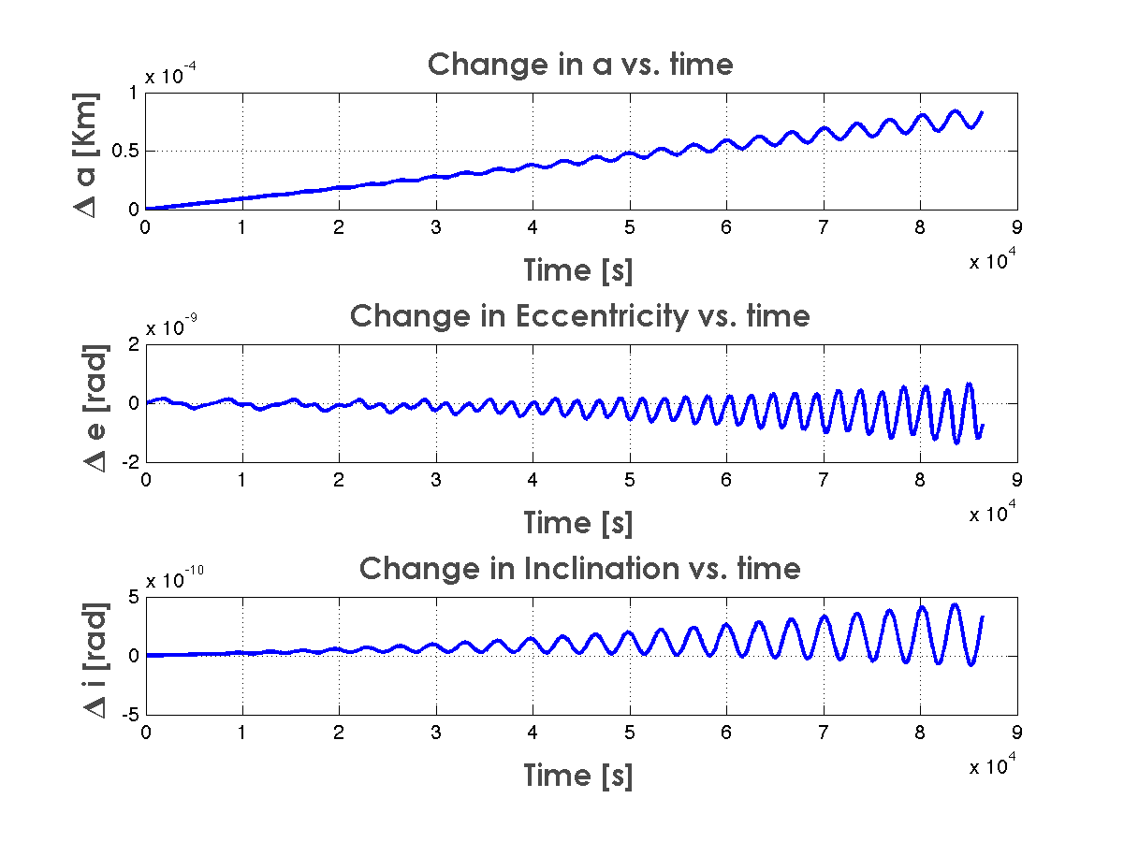

Figure 6: Change in Keplarian Elements vs. Time (1)

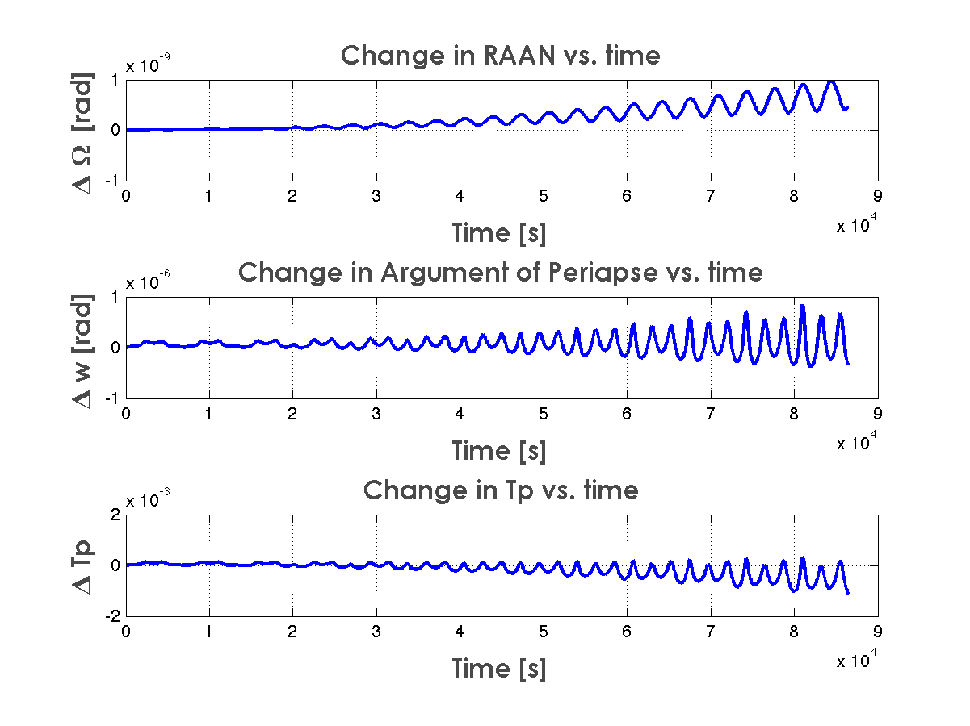

Figure 7:Change in Keplarian Elements vs. Time (2)

Each orbit element originally started off at 0 difference, which is a good indication of correctness. Then, each element begins to oscillate and drift throughout the integration time.

The semi-major axis change grows with time, and the RAAN grows as well. Less so, the inclination shows a positive change envelop. The Argument of periapsis has the most neutral change envelop throughout the exercise, and the Time since Passage and eccentricity decrease in time. This shows that the orbit eccentricity is decreasing in this case, or becoming more circular.

**Appendix A-Hand Derivation**

